DESIGN AND CREATE WEBPAGE FOR TRAVEL/RECIPE BOOK WITH MORE THAN 3 PAGES,TABLES TO LIST PLACES/RECIPE(IFRAME,HYERLINK)

RECIPE.HTML
<html>
<head>

<title>Recipe Website</title>
<style>
table, th, td {
border: 3px solid black;
color: red;
padding: 10px;
}
body {
background-color: lightblue;
color: black;
font-family: Arial, sans-serif;
}
p {
background-color: yellow;
opacity: 0.6;
padding: 10px;
font-weight: bold;
}
iframe {
border: none;
}
</style>
</head>
<body>

<h2 align ="center">RECIPE WEBSITE</h2>
<p align = "center">Select your favorite dish from the list</p>

<table align ="center">
<tr>
<th>Recipe Name</th>
<th>Link</th>
</tr>

<tr>
<td style="color: blue;">
<img src="C:\Users\Admin\Desktop\ec.jpg" height="200" width="200" alt="Lemon Rice Image">
</td>

<td>
<a href="C:\Users\Admin\Desktop\M Naveen Kumar ec\maggi.html" style="color: blue;">Click here for Maggi recipe</a>
</td>
</tr>

<tr>
<td style="color: blue;">
<img src="C:\Users\Admin\Desktop\images.jpg" height="200" width="200" alt="Lemon Rice Image">
</td>
<td>
<a href="C:\Users\Admin\Desktop\M Naveen Kumar ec\lemon.html" style="color: blue;">Click here for lemon rice recipe</a>
</td>
</tr>

</table>

</body>
</html>

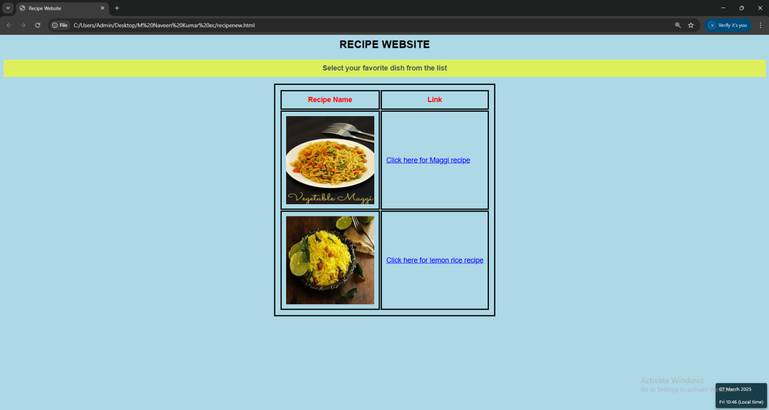

MAGGI.HTML

<html>
<head>
<style>
p{
color:black
text-bell mt:30px
text-transform:lower case;
}
</style>
</head>
<body>
<div style="background-image:yrl(1,jfif);">
<h1>RECIPE FOR MAGGI</h1>
<p>STEP 1: Boil Water: In a pan, bring 1 ½ cups of water to a boil.</p>
<p>STEP 2: Add Noodles: Break the Maggi noodle cake into smaller pieces and add it to the boiling water.</p>
<p>STEP 3:dd Tastemaker: Once the noodles start to soften, add the tastemaker (spice mix) that comes with the packet.</p>
<p>STEP 4:Cook Noodles: Stir well and cook for 2-3 minutes, or until the noodles are cooked and the water is mostly absorbed.</p>
<p>STEP 5:Serve: Once done, give it a final stir and serve hot!</p>
<p><b>Enjoy your quick and tasty Maggi!</b></p>
<img src="C:\Users\Admin\Desktop\ec.jpg"
</div>
</body>
</html>
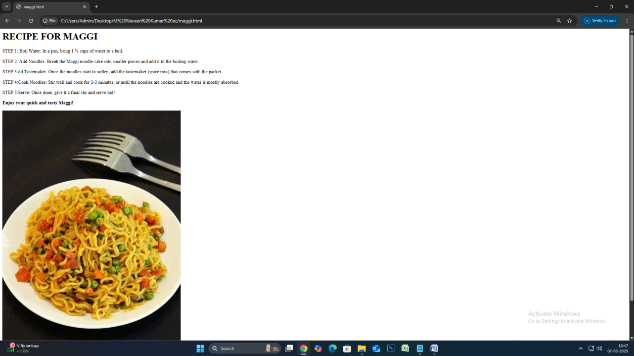

LEMON.HTML

<html>
<head>
<style>
p {
color: black;
text-align: left;
text-transform: lowercase;
margin-top: 30px;
}
</style>
</head>
<body>
<div style="background-image: url('1.jfif');">
<h1>Recipe for Lemon Rice</h1>
<p>STEP 1: Cook the rice: Cook 1 cup of rice and set it aside. Let it cool slightly.</p>
<p>STEP 2:Temper the spices: Heat oil in a pan. Add mustard seeds and let them splutter. Then, add the green chilies and sauté for a few seconds.</p>
<p>STEP 3: Add turmeric: Add turmeric powder to the pan and stir for a few seconds to release the flavor.</p>
<p>STEP 4:Combine rice: Add the cooked rice to the pan and mix well with the spices. Cook for 2-3 minutes on low heat.</p>
<p>STEP 5:Finish with lemon and salt: Pour in the lemon juice, add salt to taste, and give everything a good mix. Garnish with fresh coriander if desired.</p>
<p><b>Your lemon rice is ready to serve! Enjoy!</b></p>
<img src="C:/Users/Admin/Desktop/images.jpg" alt="Lemon Rice">
</div>
</body>
</html>

